**Covid-19 Modelling Results, as at 20 April 2020**

**CANADA**

1. **Total Confirmed Cases**

My R code for Covid-19 modelling is at

<https://raw.githubusercontent.com/DaveGiles1949/r-code/master/Canadian_Covid-19_Cases.R>

The code will automatically download the latest data from my github account.

The chart below shows results based on *data from 2 March to 20 April inclusive*.

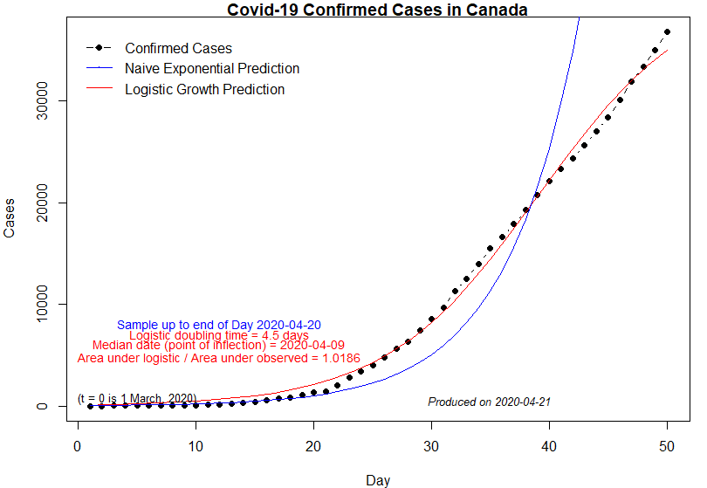

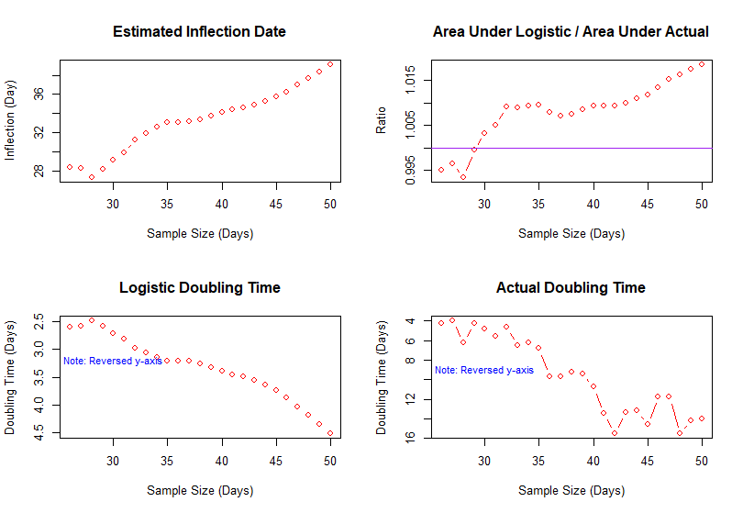

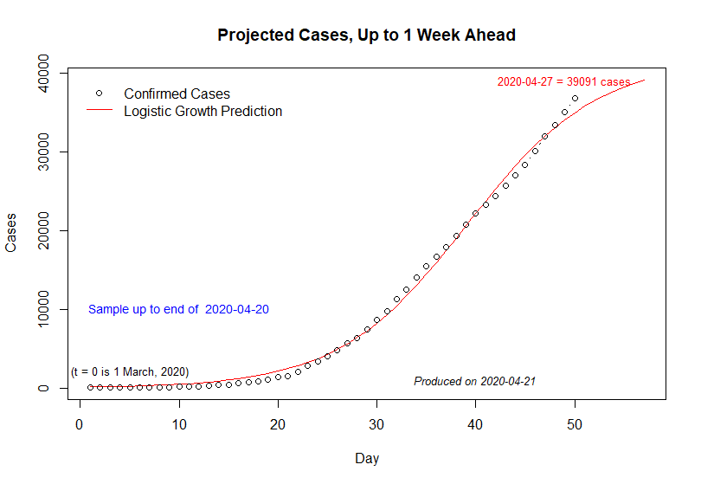

**Table 1: Projected Covid-19 Cases in Canada**

**(Projections are in Blue; Actual Values are in Brackets)**

**Sample end (projection made): 20 April**

*21 Apr 22 Apr 22 Apr 23 Apr 24 Apr 25 Apr 26 Apr*

35811 36536 37181 37753 38258 38702 39091

1. **Total Number of Deaths**

My R code for Covid-19 modelling is at

<https://raw.githubusercontent.com/DaveGiles1949/r-code/master/Canadian_Covid-19_Deaths.R>

The code will automatically download the latest data from my github account.

The chart below shows results based on *data from 14 March to 20 April inclusive*.

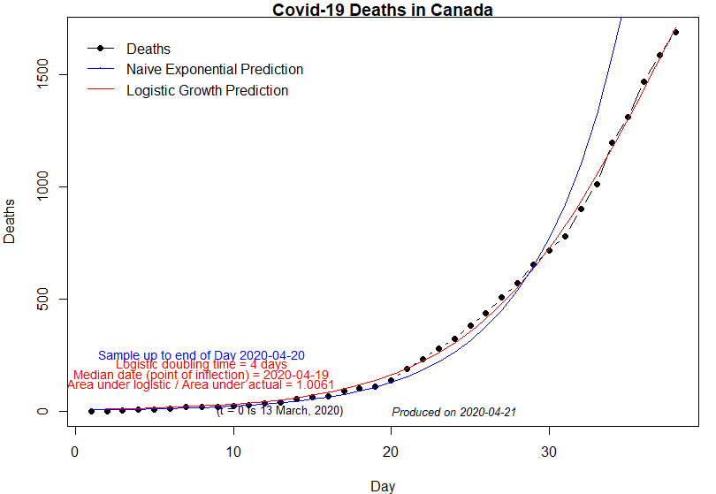

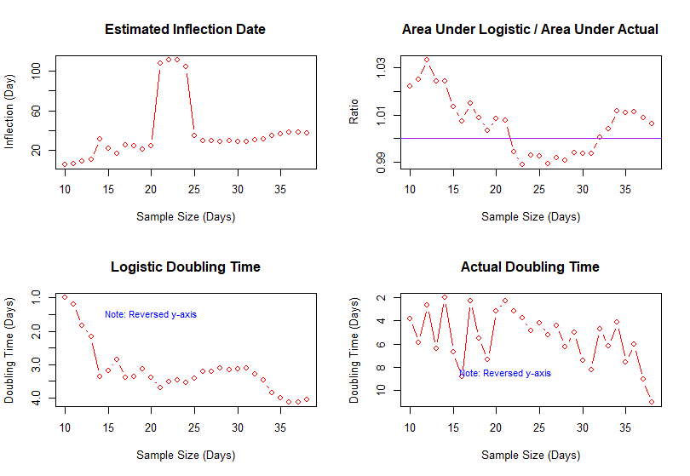

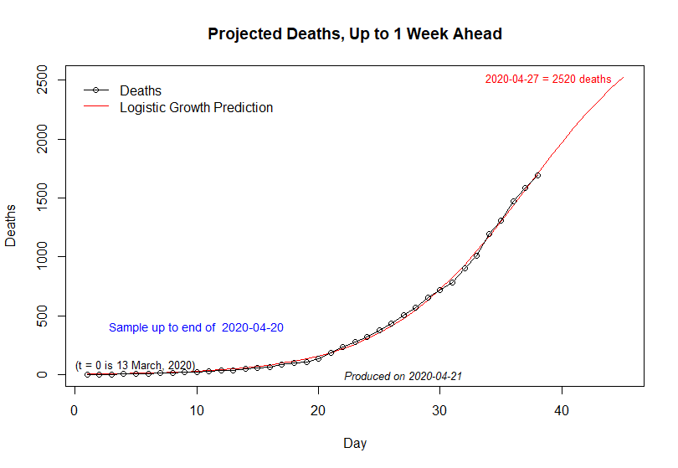

**Table 2: Projected Covid-19 Deaths in Canada**

**(Projections are in Red; Actual Values are in Brackets)**

**Sample end (projection made): 20 April**

*21 Apr 22 Apr 23 Apr 24 Apr 25 Apr 26 Apr 27 Apr*

1842 1972 2097 2215 2325 2427 2520

**ONTARIO**

1. **Total Confirmed Cases**

My R code for Covid-19 modelling is at

<https://raw.githubusercontent.com/DaveGiles1949/r-code/master/Ontario_Covid-19_Cases.R>

The code will automatically download the latest data from my github account.

The chart below shows results based on *data from 2 March to 20 April inclusive*.

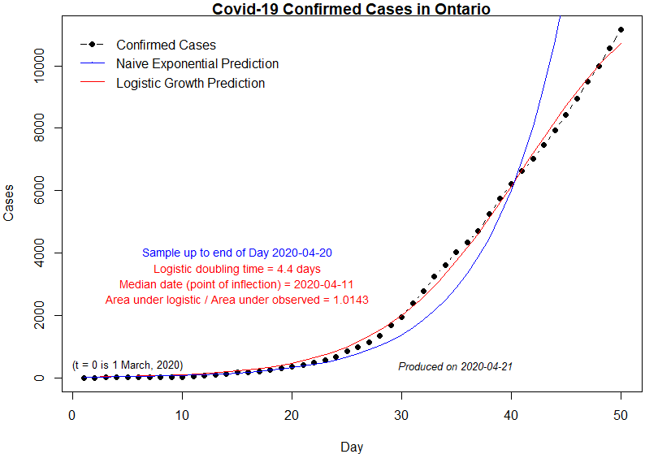

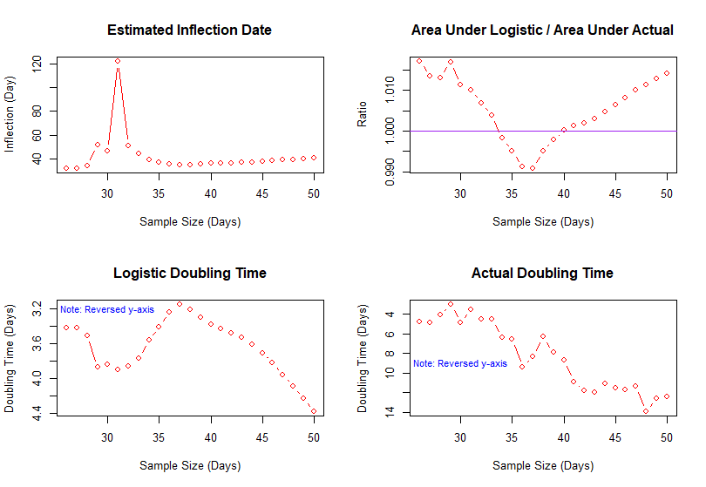

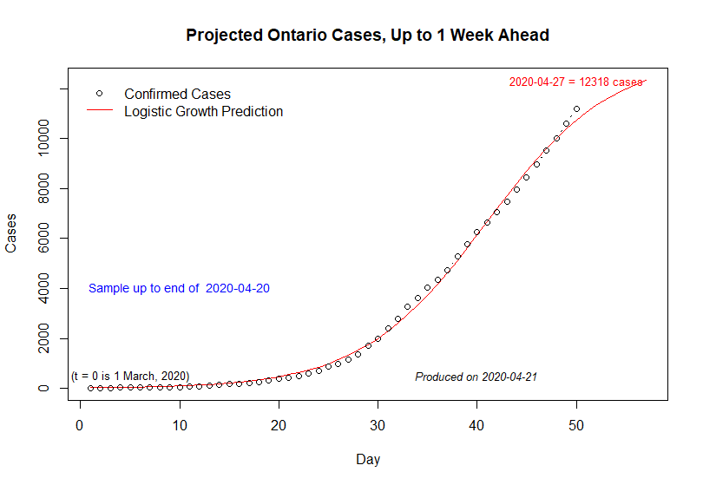

**Table 3: Projected Covid-19 Cases in Ontario**

**(Projections are in Blue; Actual Values are in Brackets)**

**Sample end (projection made): 20 April**

*21 Apr 22 Apr 23 Apr 24 Apr 25 Apr 26 Apr 27 Apr*

11037 11318 11569 11793 11991 12165 12318

1. **Total Number of Deaths**

My R code for Covid-19 modelling is at

<https://raw.githubusercontent.com/DaveGiles1949/r-code/master/Ontario_Covid-19_Deaths.R>

The code will automatically download the latest data from my github account.

The chart below shows results based on *data from 17 March to 20 April inclusive*.

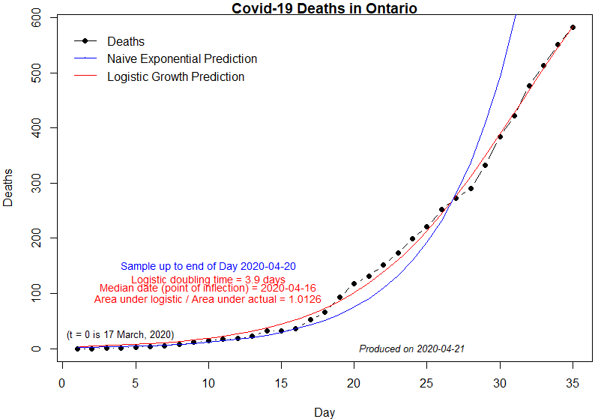

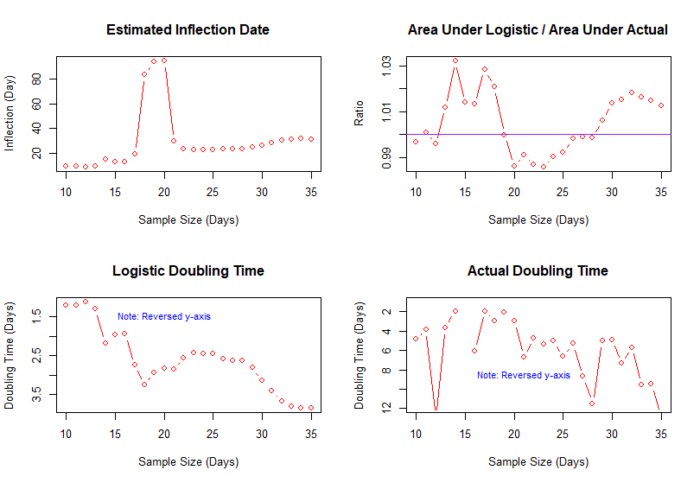

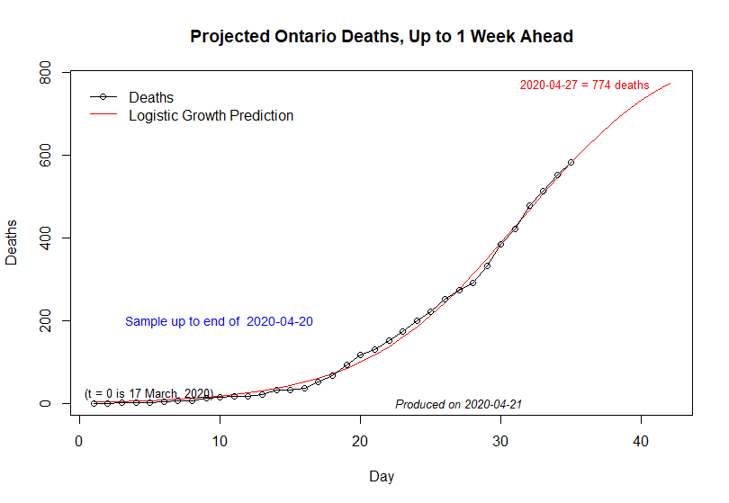

**Table 4: Projected Covid-19 Deaths in Ontario**

**(Projections are in Red; Actual Values are in Brackets)**

**Sample end (projection made): 20 April**

*21 Apr 22 Apr 23 Apr 24 Apr 25 Apr 26 Apr 27 Apr*

619 651 681 709 733 755 774